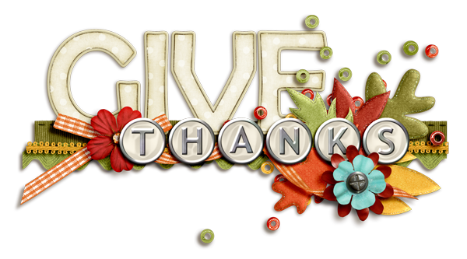

STATION 1:
PLANKSGIVING
(Plank Hold)

STATION 2:
TURKEY FEATHER FLAPPERS
(Jumping Jacks)

STATION 3:
HARVEST HOPS
(Hop back & forth across the line)

STATION 4:
PILGRIM PUSH-UPS
(Diamond Push-Ups)

STATION 5: TURKEY TROT
(Run around the cones!)

STATION 6:
PILGRIM POP UPS
(Jump Squats)

STATION 7:
FRIENDSGIVING
(Reverse Lunges with your Partner)

