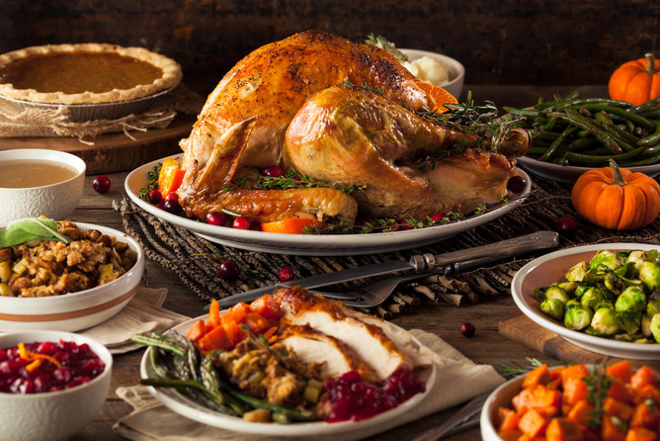

**For each food that you or your partner plan to eat on Thanksgiving Day, do the workout that corresponds with that food!**

|  |  |
| --- | --- |
| **Turkey = 30 jumping jacks** | **Rolls/biscuits= 15 push ups** |
| **Ham = High knee across gym & back** | **Greens = 20 – exercise of your choice!** |
| **Stuffing = 20 squats** | **Macaroni & Cheese = 30 sec plank** |
| **Sweet potato casserole = 20 sit ups** | **Pie = 10 burpees** |
| **Mashed potatoes = 30 sec wall sit** | **Gravy = Hip Raises** |
| **Cranberry sauce=10 Mountain climbers** | **Brussel sprouts=15 sec of your fav stretch** |