Start at Monument Avenue - going east
Turn right onto North Meadow Street – 0.59 mi
Turn right onto Colorado Avenue – 1.93 mi
Turn right onto Hampton Street – 1.97 mi
Turn left onto Amelia Street – 2.13 mi
Turn left onto Lake Road – 2.17 mi
- Passing through Byrd Park, with Shields Lake and Swan Lake to your right – 2.22 mi
Turn left onto Shirley Lane – 2.50 mi
Head straight onto Shirley Lane – 2.59 mi
- Maymont to your left and the Carillon bell tower ahead – 2.61 mi
Turn right onto Spottswood Road – 2.66 mi
SAG at Spottswood & Police Memorial
Turn left onto Police Memorial Way – 3.02 mi
- The original Byrd Park reservoir to the right – 3.14 mi
Cross Blanton Avenue and continue straight on Condie Street – 3.24 mi
Turn left onto French Street – 3.63 mi
Turn right onto Douglasdale Road – 3.70 mi
- City Stadium to the right – 3.74 mi
Turn left onto Douglasdale Road – 3.76 mi
Turn right onto Portland Place – 3.98 mi
Turn left onto Dover Road – 4.56 mi
- Passing through Windsor Farms – 4.60 mi
Turn left onto Canterbury Road – 4.85 mi
Bear right to stay on Canterbury – 4.88 mi
Continue straight onto Sulgrave – 5.11 mi
- Virginia House to the left – 5.26 mi
- Agecroft Hall to the left – 5.30 mi
Bear left to stay on Sulgrave – 5.38 mi
Bear right – 5.61 mi
Turn slight right onto Lock Lane – 5.69 mi
SAT at Old Locke & Rolfe before crossing Cary
Cross Cary to East Lock Lane – 6.12 mi
Turn left onto Grove Avenue – 6.40 mi
Turn right onto Bunting Avenue – 6.50 mi
Turn left onto Patterson Avenue – 6.83 mi
Turn left onto Maple Avenue – 7.94 mi
- St. Christopher's School to the right – 8.04 mi
Turn right onto York Road – 8.43 mi
Cross Three Chopt to Iris Lane – 8.70 mi
Turn right onto Robin Road – 8.92 mi
SAG at Robin & Irish
Continue slight left onto Fairway View Road – 9.15 mi
Turn left onto Ridgeway Road – 9.26 mi
- The Country Club of Virginia to the left – 9.34 mi
- University of Richmond campus to the right – 9.46 mi
Turn left onto Gambles Mill Eco-Corridor – 9.51 mi
Turn right - through the shopping center – 9.96 mi
Bear right onto Westham Station Road – 10.20 mi
- Passing near the original Westham Station and settlement – 10.48 mi
Turn right onto Ridge Road South – 10.85 mi
Turn slight right onto Westham Parkway – 11.32 mi
SAG at Westham & Hillsdale
Continue right onto Westham Parkway – 12.07 mi
Turn right onto Westham Parkway – 12.69 mi
Turn right onto Durwood Crescent – 13.03 mi
Turn left onto Ridge Top Road – 13.24 mi
Turn right onto Patterson Avenue – 13.48 mi
Turn left onto Charles Street – 13.75 mi
Turn right onto West Franklin Street – 13.99 mi
Turn right onto Bevridge Road – 14.45 mi
Turn left onto Dustin Drive – 14.60 mi
SAG at Dustin & Maple
Turn left onto Maple Avenue – 15.00 mi
Cross Monument and head straight onto Keystone Drive – 15.08 mi
Turn right onto Keystone Circle – 15.18 mi
Turn left onto Morningside Drive – 15.20 mi
Turn right onto Fitzhugh Avenue – 15.44 mi
Turn right onto Byrd Avenue – 16.27 mi
Turn left onto Wythe Avenue – 16.67 mi
Cross Willow Lawn Drive – 16.83 mi
Turn right onto Bromley Lane – 16.88 mi
Turn right onto Commonwealth Avenue – 17.60 mi
SAG at Lenard & Commonwealth
Turn left onto Hanover Avenue – 18.06 mi
Go left then take a quick right to stay on Hanover Avenue – 18.14 mi
Turn left onto Sauer Avenue – 18.25 mi
Turn right onto West Franklin Street – 18.62 mi
Turn left onto Kent Road – 19.02 mi
Turn right onto Monument Avenue – 19.17 mi
Turn right onto North Arthur Ashe Boulevard – 20.01 mi
End – 20.04 mi

MapMyRun: https://www.mapmyrun.com/routes/view/5929643686/
RunGo with notes: https://routes.rungoapp.com/route/DWsX0d0aVX
RunGo: https://routes.rungoapp.com/route/CQ5SSRjpCO

History along the way
Richmond in the 1920s began to expand westward. Public funds were spent on infrastructure improvements in outlying areas, including street development and sewer line extension, thus influencing the direction of suburban development. The white population moved into the city’s newly annexed suburbs and undeveloped land, and Blacks moved into the neighborhoods that whites had left.
During that same period, the city saw construction beginning on “affluent estates in the city’s west end, developed around important manor houses and reflecting a nationwide interest in the architecture of the English manor house,” wrote historian Marie Tyler-McGraw (quoted in “Richmond Through the 20th Century” by Amy Waters Yarsinske).
The growing popularity of the automobile hastened the expansion of the city and its neighborhoods, especially to the west. People no longer needed to rely on foot, horse, and trolley transportation. Faster and easier car travel also led to larger lots, as compact neighborhoods weren’t necessary, and to zoning regulations that separated houses from businesses.

Byrd Park
What’s now known as Byrd Park began with the establishment of the water reservoir in 1874, surrounded by 60-acre Reservoir Park. Fountain Lake (aka Reservoir Lake and Boat Lake) provided fill for the earthen construction of the reservoir.
The park was renamed in 1907 for Richmond founder William Byrd II. By 1917, the park had expanded and the City of Richmond added two lakes: Swan Lake and Sheilds Lake. Sheilds Lake was used as a whites-only swimming lake from 1919 to 1955. The Round House was built in 1914, replacing Rathskeller restaurant and saloon. The park is now 275 acres. https://www.nps.gov/nr/feature/places/pdfs/15001044.pdf

Maymont
The Maymont estate was completed in 1893 by a wealthy Richmond couple, James and Sallie Dooley. The estate is an example of the Gilded Age in America, 1870 to 1900. It was a time of rapid economic growth, attracting millions of European immigrants. Yet it was also a time of poverty and inequality, since not all immigrants found their pot of gold and the wealth of a few became more visible and problematic.
Upon their deaths and according to their wishes, Maymont, including the buildings and its furnishings and the 100-acre landscape was left to the people of Richmond.
From Mrs. Dooley’s death in 1925 until 1975, the property was owned and operated by the City of Richmond. When the city realized it couldn’t maintain or restore the estate to its fullest potential, control was passed to the Maymont Foundation. Today, the foundation maintains natural-setting wildlife habitats, the Maymont Children’s Farm and The Robins Nature Center as well as the Maymont Mansion. https://maymont.org/about/

The Virginia World War Memorial Carillon
Dedicated in 1932, the 240-foot-tall bell tower is the Commonwealth’s official monument to the approximately 3,700 Virginians who died as a result of World War I. The tower includes a massive musical instrument made up of 53 bronze bells.

City Stadium
Built in 1929, City Stadium has hosted a variety of sports teams. It has a long and sometimes checkered past. The stadium, built in 1929, seats approximately 22,000 people and has served a variety of purposes.

- It was used by the University of Richmond for football games from 1929 until 2009, when the school built a stadium on campus.
- It was used by a professional Richmond baseball team, the Colts, who played from 1931 to 1953.
- From 1964 through 1967, the stadium was home to Richmond Rebels of the Atlantic Coast Football League and the Continental Football League.
- Other teams using the field and stands include Richmond Roadrunners and Richmond Saints football teams and University of Richmond soccer.
- It has been used by the Richmond Kickers soccer team since 1995.
- It served as the site of the NCAA Division I Men's Soccer Championship from 1995 to 1998.
- Beginning May 11, 2024, W League RVA pre-professional women’s soccer will play its home games here.
- In 1974, the stadium was the site of the Cherry Blossom Music Festival … and a riot. Musicians included Steve Miller Band, Boz Scaggs, Dr. John and Mandrill, Kool & the Gang, and the Funkadelics. But the no-drugs-or-alcohol policy led to riots when guards began cracking down on those who’d brought drugs and alcohol into the festival.

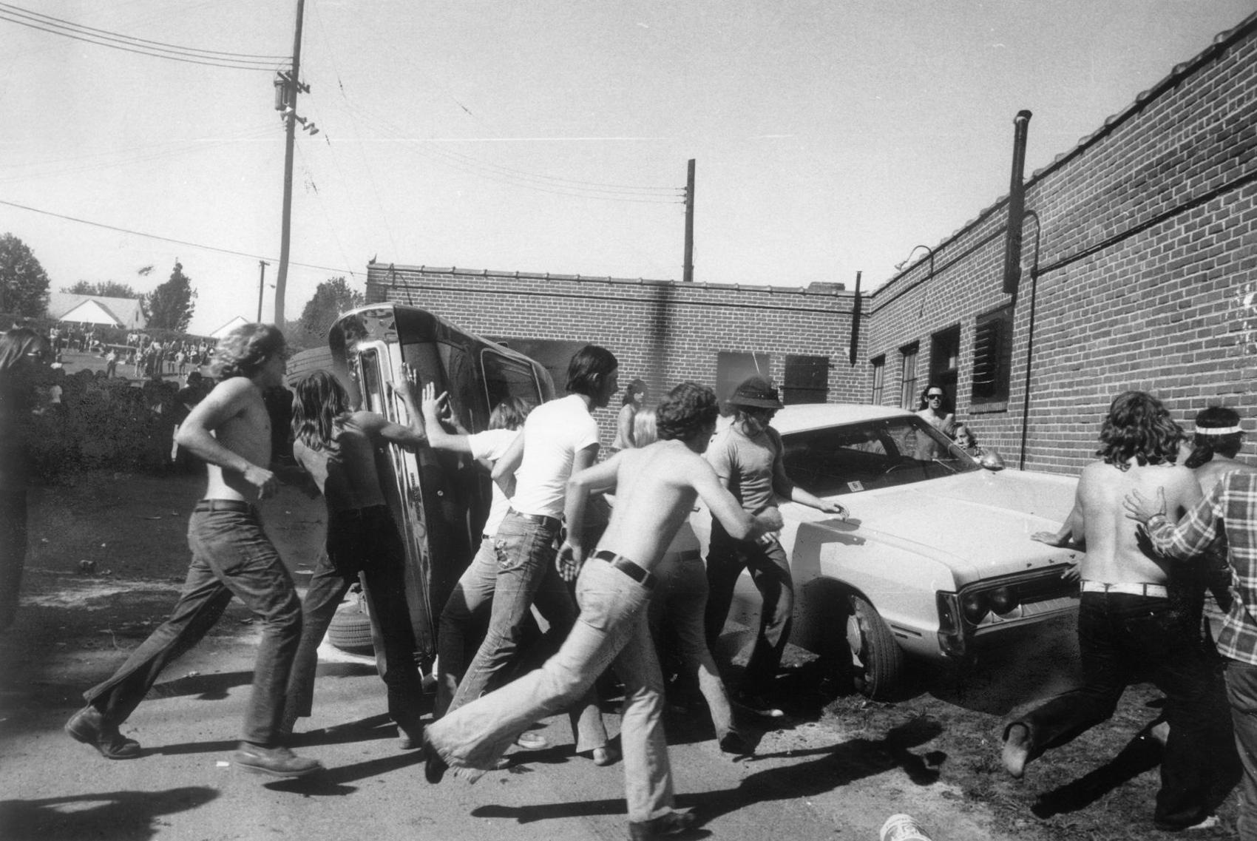

Windsor Farms
One of the grand English manor houses built in the 1920s was Agecroft Hall, which Richmond T. C. Williams Jr. arranged to have transported from England. The house at that time was already centuries old, probably from the late 15th to early 16th century. Williams had the house dismantled, shipped across the Atlantic, and reconstructed. The project was completed in 1928.
Another nod to the English manor house was Virginia House. In 1925, Alexander and Virginia Weddell bought Warwick Priory in England at a demolition sale. They had the house dismantled and rebuilt part of it in Richmond. The center section of the new structure was a reproduction of the original priority, and the west wing was designed after Sulgrave Manor, which was an ancestral home of George Washington. The house was completed in 1928. The couple planned for the west wing to serve as a museum for the Virginia Historical Society and the entire house to serve as the society’s headquarters later, so they deed the house to the VHS (now the Virginia Museum of History & Culture) and maintained a lifetime tenancy for themselves.
T. C. Williams Jr. developed the Windsor farms neighborhood around these two homes, Windsor Farms was designed after English villages, centered on a common green, with English-inspired street names such as “Dover,” “Oxford,” “Coventry,” and “Canterbury.” Homes were designed primarily in Georgian-style architecture.
A network of 11 miles of curving streets fashioned in circular and diagonal patterns resulted in 557 lots ranging from ½ acre to 23 acres. Larger lots could be found at the southern side by the James River, with smaller lots on the north along Cary Street and near the open common.
The common area included shops and services, including a town hall, library, bank, school, and church, approached from the north by a tree-lined boulevard, Windsor Way. Nolen provided two parks – Riverview Park in the south and Battery Park in the east – encompassing more than 50 acres. The neighborhood was advertised as a combination of country and village living a short distance from the city.
https://www.tclf.org/landscapes/windsor-farms

Other nearby growth
- Just upriver from Windsor Farms, another grand English-style house was erected. Wilton was initially built in 1753 on the James River east of Richmond by the Randolph family. The property was sold in the 19th century to pay family debts, then went into foreclosure during the Great Depression. It was purchased by The National Society of The Colonial Dames of America in 1932 and moved to Richmond’s expanding west end.
- The Country Club of Virginia was established here in 1910.
- Richmond College (now the University of Richmond), moved from its campus in The Fan in 1914.
- Saint Christopher’s School for Boys, founded in 1911, moved to its present location in 1914.
- St. Catherine’s School for Girls, founded in 1890, moved to the area in 1917.

Westham
The original Westham community, called Beverley, was established west of the James River fall line, where the rapids begin, to connect river and land transportation. The village of Westham was established in the 1752 on the north bank of the James. This placement enabled the town to receive tobacco and other wares shipped from upriver. A trading post was established where today’s Huguenot Bridge meets the north shore of the river today.
The town and rebuilt foundry had a brief resurgence in the 1860s, producing iron for munitions made at Tredegar Iron Works.
In 1911, Westham Station was built as a railroad stop, and Westham Bridge was built to cross the river, just west of the current Huguenot Bridge.
As the city suburbs expanded west, the neighborhoods adopted Westham as its moniker.
The toll bridge was replaced by the Huguenot Memorial Bridge, named for French Huguenot Settlers, in 1950.

