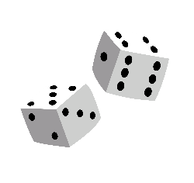 **ROLL THE DICE WORKOUT **

|  |  |
| --- | --- |
| **Roll 2** | **30 Second Plank** |
| **Roll 3** | **Student Choice** |
| **Roll 4** | **1 minute of Fast Feet Drop** |
| **Roll 5** | **30 Seconds Overhead Tricep Extension** |
| **Roll 6** | **30 Second Wall Sit** |
| **Roll 7** | **Lucky #7 – Water break!** |
| **Roll 8** | **8 Push Ups** |
| **Roll 9** | **9 Burpees** |
| **Roll 10** | **10 Elbow, Elbow, Hand, Hand** |
| **Roll 11** | **30 Seconds Overhead Press** |
| **Roll 12** | **Jog In Place For 1 Minute** |