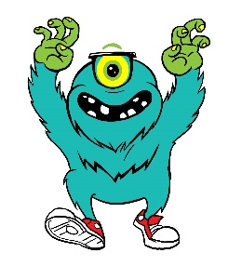  This Photo by Unknown Author is licensed under CC BY-NC-ND  PUSH UPS | This Photo by Unknown Author is licensed under CC BY-NC-ND  SIT UPS
This Photo by Unknown Author is licensed under CC BY-NC-ND  JUMPING JACKS | This Photo by Unknown Author is licensed under CC BY-NC-ND  MOUNTAIN CLIMBERS
This Photo by Unknown Author is licensed under CC BY-NC-ND  PLANK | This Photo by Unknown Author is licensed under CC BY-NC-ND  LEG LIFTS
This Photo by Unknown Author is licensed under CC BY-NC-ND  SQUATS | This Photo by Unknown Author is licensed under CC BY-NC-ND  CALF RAISES
This Photo by Unknown Author is licensed under CC BY-NC-ND  WASHING MACHINES | This Photo by Unknown Author is licensed under CC BY-NC-ND  LUNGES
This Photo by Unknown Author is licensed under CC BY-NC-ND  SUPERMAN | This Photo by Unknown Author is licensed under CC BY-NC-ND  TREE POSE

