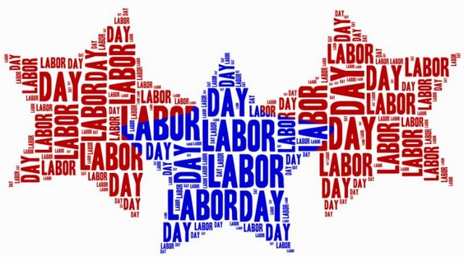

KIDS RUN RVA LABOR DAY WORKOUT

Do 30 seconds of each Red, White, and Blue exercise below.

In between each round do 10 Star Jumps!

|  |  |
| --- | --- |
| R | Russian Twists |
| E | Exercise of your choice |
| D | Donkey Kicks |

|  |  |
| --- | --- |
| **W** | **Wall Sit** |
| **H** | **High Knees** |
| **I** | **Ice Skaters** |
| **T** | **Toe Touches** |
| **E** | **Exercise of your choice** |

|  |  |
| --- | --- |
| B | Burpees |
| L | Lunges |
| U | Upright Rows |
| E | Exercise of your choice |