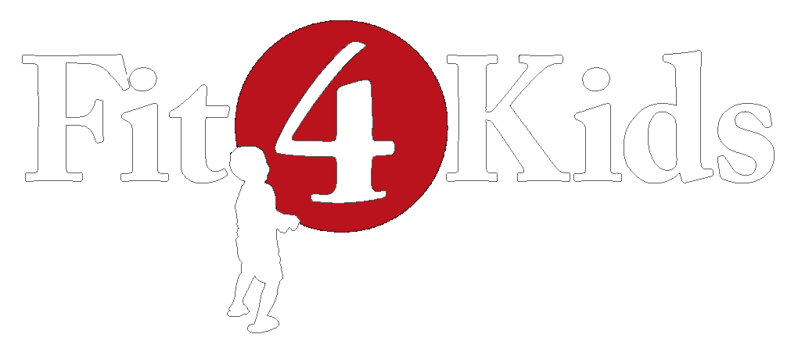

|  |
| --- |
| **Halloween-Town Mingle** |

|  |
| --- |
| **Introduction**  The instructor explains that she is the Queen of Halloween Town and is going to give commands to the townspeople to perform a specific movement as they travel through the town. |

|  |
| --- |
| **Directions**   1. Before beginning, explain a few of the below commands and show corresponding movements. Explain that to survive the treacherous Halloween Town, the townspeople must work together and follow the Queen’s commands. If a townsperson is not able to find a partner for the commands that require one, she will come to the side of the playing area, perform 10 pumpkin squats (squat like you’re holding a big, heavy pumpkin), and may return back to town. 2. Play will begin with all participants lined up in the middle of the boundary for a town roll call.. 3. To begin call out “mingle” and the students will walk around chatting and mingling with the other townspeople. Then call out each of the commands listed below and participants will perform the corresponding action. Introducing a few at a time may help participants remember the actions.   **Commands:**   * **Mingle** – walk around the playing area * **Thriller** – arms bent in a 90 degree ankle moving left to right, like Michael Jackson’s dance * **Picking pumpkins** – squat down and pretend to pick pumpkins * **Ghost hunting** – squat down low walking around with hand above eyebrows * **Zombie walk** – hands straight out in front and walk on heels * **Monster marathon** – walking around like a monster * **Creepy spider** – crab walk – sit on the floor with your knees bent, your palms slightly behind your hips, and your feet flat on the floor. Lift your glutes a couple inches off the floor. This is the starting position. Simultaneously “walk” your right hand forward a few inches while straightening your left leg in front of you. * **Flying bats** – walking/running while flapping arms like wings * **Creepy inchworm** - bend down to touch the ground in front of toes, keeping legs and arms straight. Keep feet planted as you walk hands out until you reach a plank. Then walk your feet to meet your hands.   **Group Commands:**   * **Haunted house** (need 2) – two friends with arms up touching, making a roof * **Witches brew** (need 2) – two friends squat in front of each other and stir ‘cauldron’ in front of them * **Jack in the box** (need 3) – two friends stretch arms out and touch hands, 1 friend in the middle pops up * **Black cat** (need 2) – two friends in plank position, high 5 with the same hand 6 times. |

|  |
| --- |
| **Cool Down**  Smelly toe stretch – reach up to the sky and down to your toes three times. Take three deep breaths to calm the body and mind. |

|  |  |  |
| --- | --- | --- |
| www.grfit4kids.org | Greater Richmond Fit4Kids | @gr_fit4kids |