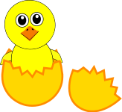 3 Burpees |  3 Burpees
5 Push Ups | 5 Push Ups
Run 1 lap | Run 1 lap
10 sit ups | 10 sit ups
10 second plank | 10 second plank
7 frog jumps | 7 frog jumps
8 jumping jacks | 8 jumping jacks
6 squats | 6 squats

