

**JUMPING JACKS**



**SQUATS**

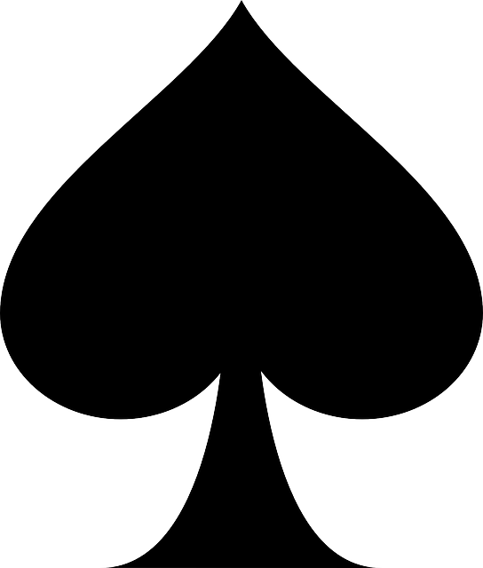

**MOUNTAIN CLIMBERS**



**PUSH UPS**

|  |  |
| --- | --- |
| **CARD VALUE** | **NUMBER OF EXERCISES** |
| **2 – 10** | **# shown on card** |
| **J, Q, K** | **10** |
| **ACE** | **1** |