Capstone Project, presented by Williams Mullen
ALL Stars will work within their crew, with the support of their mentors, to utilize what they have learned to address an identified need in the active living community. The goal of the capstone project is for ALL Stars to make a direct and lasting impact on active living opportunities in our community. The capstone project will be completed between February – April of 2024 and presented during graduation.
The Capstone Project proposal will need to be approved and can include, but is not limited to, initiatives such as renovating an active living space, creating a social media campaign, developing content, fundraising, or researching and developing a prototype for an active living organization.
Through generous support from Williams Mullen, each crew can be awarded up to $500 in financial support to help complete their capstone project. This funding will need to be requested at the time of submitting the capstone proposal and is subject to approval.

Capstone Project Deliverables Timeline
Deliverable | Timeline
Crew meeting to discuss capstone project plans, crew roles | By 2/4
Capstone proposal submitted | By 2/11
Approval/feedback from Sports Backers | By 2/25
Capstone projects facilitated | Mid-February – Mid-April
Capstone presentations due for approval/feedback | 4/21
Capstone presentations | At graduation, tentatively 5/5

Capstone Project Roles
Crew Leader/Communication Liaison - Acts as a point of contact between the crew, mentor, program staff, and external stakeholders. Monitors the quality of the group's work and ensures that it aligns with the outlined expectations.
Task Manager – Organizes and assigns tasks to crew members, ensuring that everyone knows what they're responsible for and deadlines are met.
Historian - Responsible for documenting key points, decisions, and action items during meetings. They create a record that helps the group recall discussions and track progress. They are also responsible for documenting the project through pictures, videos, and social media.
Resource Manager - Responsible for acquiring and managing the resources needed for the capstone project, whether that's physical resources, information, or expertise. Takes the lead on the project budget and fiduciary responsibilities.
Mentor – Helps facilitate crew discussions, ensuring everyone has an opportunity to speak, and keeps the conversation on track. Mentors will be focused on managing the process rather than dictating content. Mentors will encourage creative thinking and idea generation within the group and will help find common ground among differing opinions.
Capstone Proposal
- Seek support and input from your mentors as you plan and before you submit your proposal
- Proposal is due by 2/11/24
- Crew leader or historian should complete the proposal with input from all crew members
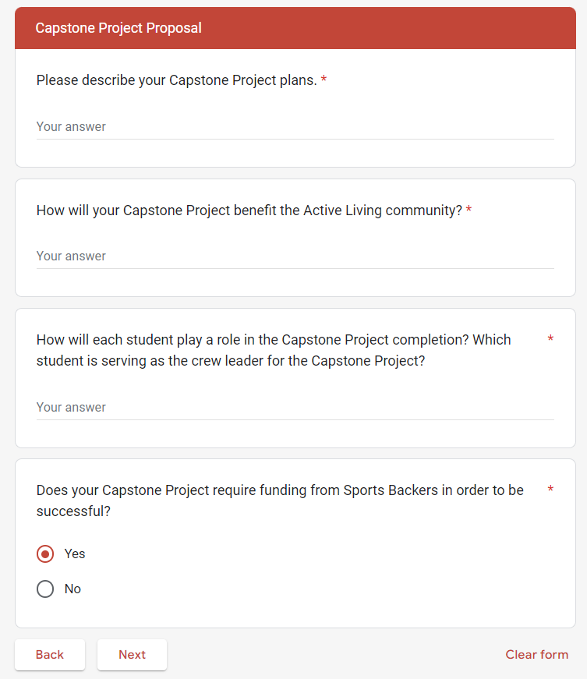
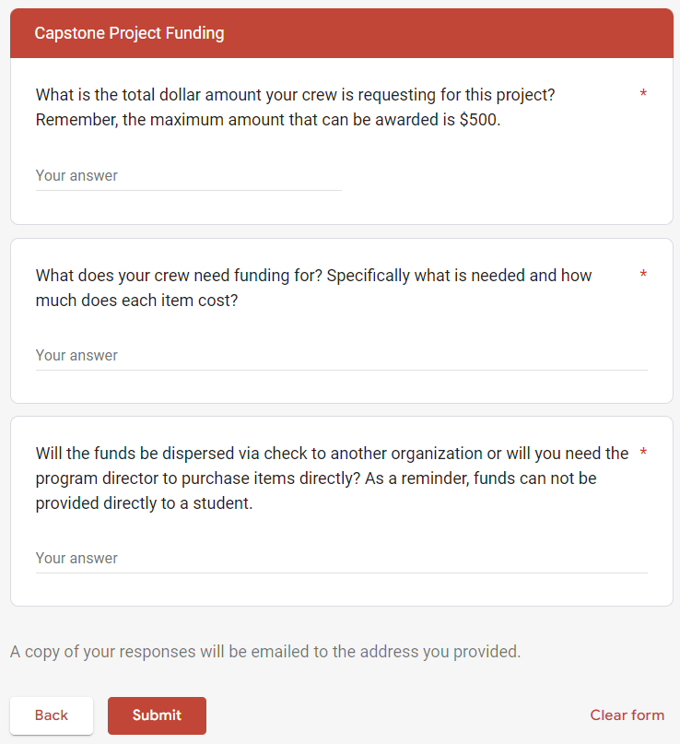

Capstone Requirements
- All crew members must play an active role throughout the capstone project.
- The project must be related to active living (ex – fitness, sport, exercise).
- The project should meet a need in the community that wouldn’t otherwise be met.
- The project should stretch your current abilities and experience.

Types of Capstone Projects
- Renovating an active living space – Is there a blacktop at a local school that could be transformed to an active play space or a local basketball court that could be beautified to make it more appealing?
- Creating a social media campaign – Is there a local non-profit with a limited budget who could benefit from a marketing plan and content generation for their programs or services?
- Developing content – Is your crew able to create video content that helps promote a local program, encourages kids to get moving, or could be used by organizations to promote a positive message related to active living?
- Fundraising – Is there a local organization that could achieve a goal with some additional funding? Can you rally your crew to host a peer-to-peer fundraising campaign or fundraising event?
- Researching and developing an initiative – Is there a local non-profit that has an idea, project, or initiation they haven’t been able to bring to fruition due to staff time limitations? Could your crew research best practices from across the country and put together a prototype for the organization to consider?
- Advocating for change – Is there something that you want to see changed? How can you use your influence as an athlete and leader to advocate for the change you want to see?
Regardless of the type of Capstone Project your crew decides on, it cannot be done in silo. You will need to be working with an organization that agrees to be a part of the project and will need to collaborate with that organization throughout the project's duration.
Presentation of Capstone Projects
Each crew will be required to present their Capstone Project at the graduation ceremony. This can be in the form of a video or slide show, unless your crew is interested in another method of presentation. A few things to keep in mind:
- Presentation plans and materials must be submitted by 4/21 in order to be incorporated into the run of show and to ensure the format is functional and acceptable.
- Presentations should be no longer than 5 minutes.
- The presentation should focus on the outcome and impact of your project. You won’t have time to detail all of the process and work that went into the project – what’s most important is that the audience knows the impact that your crew was able to make through your project.

