RRRC WMTT Feb. 24, 2024 – 8 miles
Richmond Transportation History Highlights

Start at Arthur Ashe Boulevard - going south
Turn left onto West Main Street – 0.56 mi
Turn right onto South Cherry Street – 1.92 mi
Turn left onto Spring Street – 2.39 mi
Turn right onto South Pine Street – 2.52 mi
Turn left onto Oregon Hill Parkway - which turns into 2nd Street – 2.78 mi
Turn right onto Brown's Island Way – 2.92 mi
Turn left onto Tredegar Street – 3.05 mi
- The Headman bateauman sculpture across the canal on Brown's Island represents Richmond's early water transportation – 3.24 mi
Continue straight around the traffic circle. The road becomes 7th Street – 3.33 mi
Continue left - The road becomes 10th Street – 3.53 mi
SAG AT BYRD AND 10TH
Turn right onto East Byrd Street - Stay on the sidewalk as traffic is behind you – 3.63 mi
Bear right across the cobblestones, to the right of the floodwall, then through the floodwall – 3.72 mi
Continue left onto Virginia Street – 3.89 mi
Turn right onto Canal Walk - down the stairs just after the historic marker for James River Bateaumen – 3.94 mi
Go onto the bridge over the canal. The triple crossing railroad bridge is ahead of you. Cross the canal and return the direction you came. – 4.05 mi
- The widening of the canal represents the turning basin. Above the turning basin is the Southern Railway building and Shockoe Slip – 4.16 mi
Continue left onto Canal Walk – 4.18 mi
- Note the small model of the locks – 4.22 mi
Follow the Canal Walk up the stairs, passing the Tidewater Connection Locks – 4.32 mi
Turn right onto East Byrd Street – 4.39 mi
Turn right onto East Main Street – 4.60 mi
- Main Street Station on the left – 4.88 mi
Turn right onto South 17th Street – 4.97 mi
Turn right onto East Cary Street – 5.04 mi
- Running through Shockoe Bottom – 5.11 mi
- Running through Shockoe Slip – 5.28 mi
- The James Center and the Wind's Up sculpture on the left – 5.46 mi
Turn right onto South 1st Street – 6.07 mi
Turn left onto East Franklin Street – 6.22 mi
Turn right onto Monument Avenue – 7.43 mi
End at Monument Avenue – 8.12 mi

MapMyRun: https://www.mapmyrun.com/routes/view/5923519228/
RunGo: https://routes.rungoapp.com/route/gc3o1PQdgg
RunGo with notes: https://routes.rungoapp.com/route/WhuWH331A1

Richmond Transportation Highlights

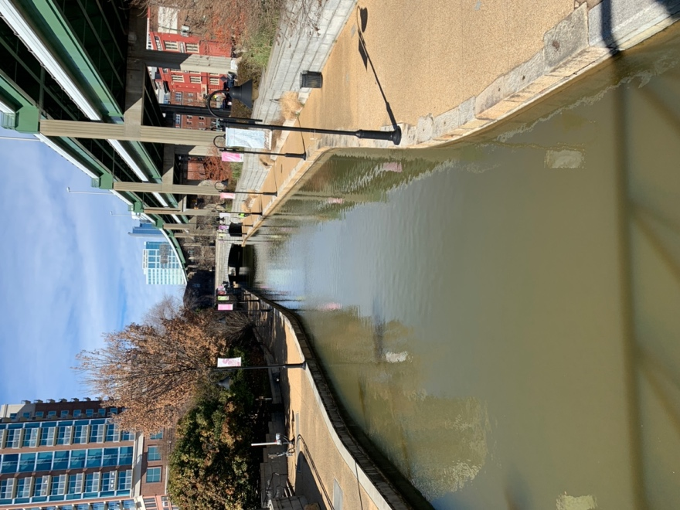

Richmond as a city exists because of transportation considerations. It’s located at the “fall line,” a geological formation that runs along the east coast of North America. As the land drops, the rivers plunge over falls and rapids. In Richmond, the fall line extends seven miles and drops 105 feet. For early English settlers, this meant that river navigation from Jamestown and other settlement downriver ended here.
George Washington and other early Virginia leaders proposed building a system of canals and locks that would continue westward into the Virginia mountains, carrying passengers and freight. Construction on these began in 1785 as the James River Company, and later restarted under the James River and Kanawha Canal Company.
Primary transportation came from man-powered bateaux and from packets pulled by horses and mules trudging along the towpath. In its peak years, the James River and Kanawha Canal employed 75 deck boats, 66 open boats, 54 batteaux, 6 passenger boats, 425 horses, and 900 men. The project never fully came to fruition. By 1851, it was only half completed, reaching Botetourt County near Roanoke. The rise of railroads halted the idea entirely. Soon after the Civil War, railroad tracks were laid over canal towpaths.
“Richmond has been served by multiple railroads since the 1830s,” according to the Richmond Railroad Museum. “The five lines fanning out from the city in 1861 were a major reason for choosing Richmond as the capital of the Confederacy. With rail consolidation after the war, the names changed but for much of the 20th century the city still hosted six major lines. The corporate headquarters of the Richmond, Fredericksburg and Potomac (RF&P) Railroad, and CSX were located in the city.”
For early “commuters,” horse-powered omnibuses took passengers along rails laid in the road from 1860 to 1887 (excepting a few years during the Civil War). One line followed Main Street from Jefferson Street to 28th. Another ran on Broad Street from 9th Street to Brook Road, with a connecting track at 9th. Other lines were built later, including an East-End / Fulton extension and a Manchester line.
Railroads provided wealth for many influential white Richmonders. James Dooley, who owned Maymont mansion and estate, was one of the investors and developers of local rail companies, including the Richmond and Danville, Chesapeake and Ohio, and Seaboard Air Line Railroad.
Electric trolley service began regular operation in Richmond on Feb. 2, 1888, the first successful electric trolley system in the world. The tops of the new cars were connected to an electrical line called a “troller” and thus the name “trolleys.” The ability to easily transport riders farther out of town initiated the development of neighborhoods and amusement centers – including Lakeside in Richmond’s Northside and Forest Hill Park south of the river. Richmond’s trolley system operated till 1949.

Atlantic Coastline Railroad Bridge, aka CSX A-Line Railroad Bridge or James River Arch Bridge
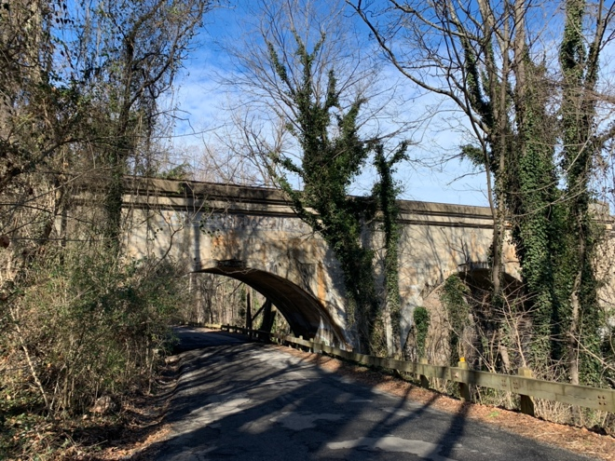
The railroad bridge was built to circumvent the slow train traffic through downtown Richmond. Before this bridge, a narrower steel truss bridge was functional but subject to rust and vibration-related maintenance and had only one set of tracks. Because the rail line formed a partial belt around part of the city, it was known as the Belt Line Bridge. The stone pilings from the first bridge are still in the River and still visible. This new bridge, made of reinforced concrete, was constructed in 1919, has two sets of tracks, and was connected to a wide network of rail lines when train travel was in its heyday. Its mix of large and small arches is an ancient but highly practical design that can carry a great deal of weight. The key to this strength is in the roughly triangular stone that rests in the top of each arch dash, called the “key stone.”

Forest Hill Park
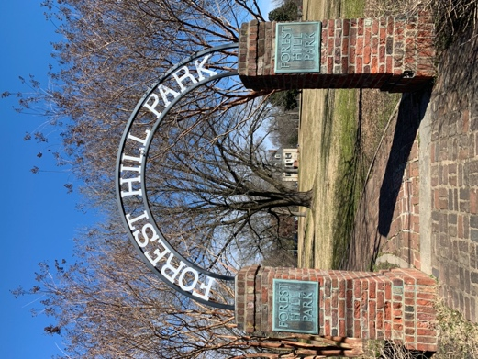
This 105-acre site was part of William Byrd III’s vast 1700s holdings along the James River. Holden Rhodes (1799 to 1857), early president of the Richmond and Petersburg Railroad Company, purchased the property in 1836, named it Boscobel, and built what is now known as the Stone House. In 1890, the Richmond and Manchester Railway Company established a trolley terminus and an amusement park here called Forest Hill Park. The amusement structures were dismantled in 1932, and the City of Richmond acquired the land in 1934.

Manchester and Free Bridges
For years, the only river crossing for vehicles and pedestrians was Mayo’s toll bridge, at 14th Street. Complaints about the tolls eventually led to the opening of Richmond’s first “free” bridge in 1873. The bridge was replaced in 1972 by the Manchester Bridge, which includes a legally mandated free walkway.

Repurposed railroad stations
Several stations from the heyday of railroad travel and freight shipping. Main Street Station in Shockoe Bottom is now mostly a large event space. Broad Street Station is the Science Museum of Virginia. And the SR Station on Hull Street is the Richmond Railroad Museum. The museum offers the chance to learn more about railroad history in Richmond and beyond, to enjoy a room filled with model railroads chugging through settings inspired by Richmond and Virginia, and to climb aboard a caboose.

James River and Kanawha Canal and the Canal Walk
The 138-acre James River and Kanawha Canal Historic District was listed on the National Register of Historic Places in 1971. In the late 20th century, the canals were reconstructed as part of a broad vision for downtown Richmond’s riverfront. Design and construction lasted from 1991 till 1999. June 4, 1999 saw the opening ceremony for the Canal Walk. The walk stretches 1¼ miles along the canal and has access points at nearly every block between 5th and 17th streets.
https://venturerichmond.com/explore-downtown/riverfront-canal-walk/

The C&O Viaduct
Now called the CSX Viaduct (from a change in railroad lines), this double-track raised railroad is about three miles long. When construction was completed in 1901, it was the longest or second longest railroad viaduct or bridge in the U.S. It starts beneath the Lee Bridge and stretches to Nicholson Street and the former Fulton Yard near Rockett’s Landing. It allows a nearly at-grade train crossing of downtown Richmond.

The Triple Crossing railroad bridge
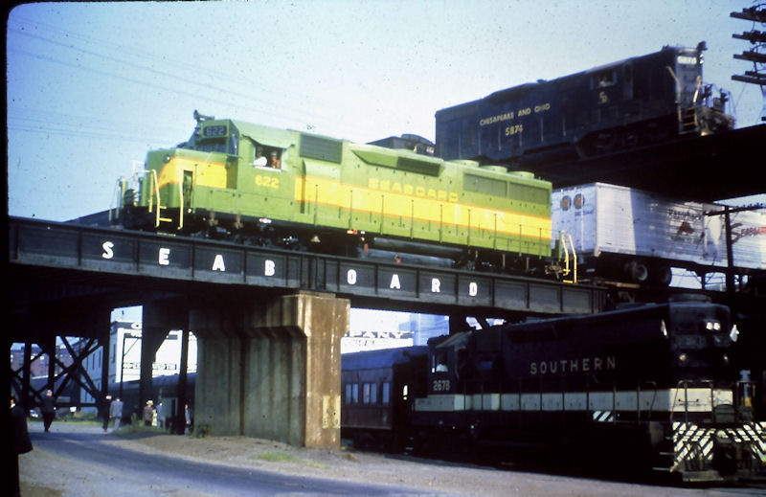
This is believed to be the only place where three railroads cross at a single point. The highest of the three is the viaduct; at mid-level is a single track of CSX Transportation (formerly Atlantic Coast Line); and at ground level, a single track Norfolk Southern Railway (formerly the Southern Railway).

Shockoe Bottom
Shockoe was the city’s first neighborhood. The name “Shockoe” came from a creek that once flowed here, after “Shacquohocan,” the Indian word for the large, flat stones at the mouth of the creek. The “Bottom” came from, well, the fact that the land is at the bottom of the surrounding hills – a fact that has been evident during floods through the centuries since Richmond was first established here.

The Turning Basin
The widening of the canal allowed boats to easily turn around, thus it was called the Turning Basin. Richmond’s original Great Basin stood between 8th and 11th, and Cary and Canal streets.

Southern Railway Building
At South 14th Street and East Canal Street stood the Southern Railway’s freight station, which is now home to Southern Railway Taphouse and other businesses.

Tidewater Connection Locks and Tidewater Lock View
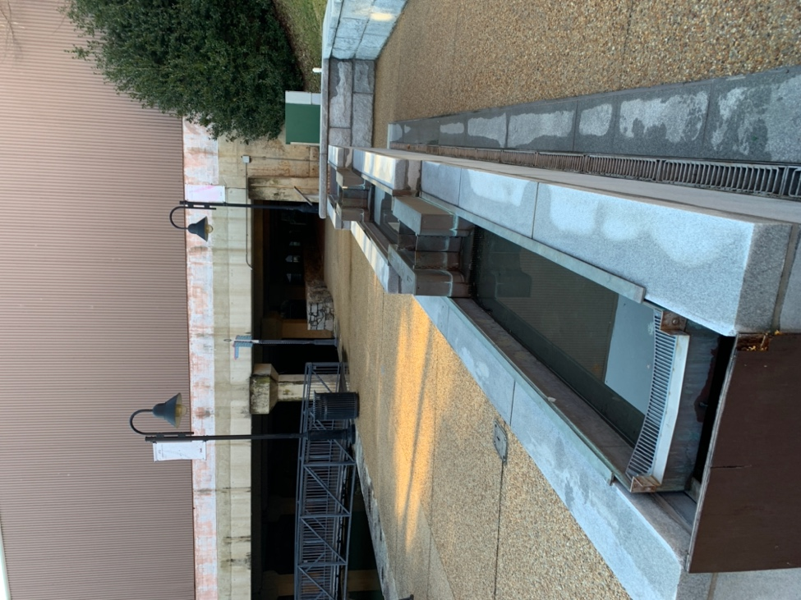
Canals and the locks that raised boats from one water level to the next were considered among the greatest engineering feats of their time. Richmond’s two remaining canal locks connected the Great Basin, between 8th and 11th Streets, with the Richmond dock at 14th Street.

Shockoe Slip
The “Slip” was aptly named for the boat slip at the canal’s Turning Basin, where cargo was loaded and unloaded. In young Richmond, Shockoe Slip was the city’s commercial center, with bustling shops, tobacco warehouses, slave trade businesses, and taverns as well as residences. From Colonial times through World War II, Richmond was a center for tobacco inspection and processing. By the mid-19th century, it the largest tobacco producer in the world, with more than 50 factories, including chewing tobacco and cigar manufacturers, box makers, and label printers. In the early 1970s, Shockoe Slip was rejuvenated as a business and entertainment destination.

The James Center
Most of what is now the James Center was occupied by the Turning Basin of the James River and Kanawha Canal. Much of the public art at the James Center reflects the history of the canal and water navigation, including:

- “Wind’s Up,” three bronze figures straining against lines to hoist the sails up a 50-foot mast.
- A bronze piece imbedded in the floor of the James Center Atrium, based on an 1857 lithograph. It features the canal and locks and the James River as they flowed in and out of the Turning Basin as well as the Richmond street grid of 1813 (not so different from today).
- Clock Tower, depicting life on the canal from 1785-1879. The 45-foot limestone tower houses a 25 brass bell carillon. As the bells chime, cast figures of canal bargemen rotate.
- Old stones from the Kanawha Canal placed in the plaza as retaining walls and seating, some to suggest the shape, size, and workings of the old locks.

https://www.thejamescenter.com/public-art/

